**User Guidelines – Project KSHEMA**

**Roles – social worker, supervisor and admin**

* + - * **SOCIAL WORKER LOGIN** – Tablet version (Galaxy Samsung Tab A, landscape mode is allowed)
* Download and install the APK in the device from the link
* Allow read and write permission when the message is displayed <#permission>
* Login using valid login credentials <#login>
* **Dashboard view** 
  + - In the very first login, dashboard will not show any data <#dashboard_null>
    - Social worker has to add patients first by clicking the add patient button <#Addpatient>
* social worker can see the consultations and tasks follow-up date of added patients, if exists, (of active patients only) under the buttons Todays, Upcoming, Overdue or Completed based on the consultations and tasks checkbox selection on the right side of the page
* Consultations checkbox checked – shows the consultations only (based on today, upcoming or overdue button selection) <#dashboard_data>
* Tasks checkbox checked – shows the tasks data only (based on today, upcoming or overdue button selection) <#tasks>
* Both consultations and tasks checkboxes checked – shows all data (based on today, upcoming or overdue button selection)
* Consultations checkbox and Todays actions button are checked by default.
* When the social worker logins, s/he can see today’s consultations
* Consultations can be Clinic, Home or Phone. If there are multiple consultations for a patient, only the latest one with the next follow-up date is displayed (under Todays, upcoming or overdue)
* Tasks can be rehabilitation measures, welfare module, udidand medicine refill
* If there are multiple tasks for a patient, only most recent task by date is displayed (under Todays, upcoming, overdue, completed)
* Remaining number will be displayed at the left top corner of the tasks column in the patient row
* Top horizontal bar in dashboard – has different buttons like Add patient, notes, home, logout etc.
* Add patient button – to add a new patient <#Addpatient>
* Notes button – if there are any notes from the supervisor for a patient, then the count of unread notes will be displayed here <#dashboard_data> <#notification>
* 4 colored boxes – shows the count of consultations, tasks, both consultations and tasks and the total number of patients (including active and inactive patients[).](#allpatients) If the user clicks on the cards, it will display the consultations/tasks in the table below (checkbox selection is also considered here)
* 4 buttons below the boxes – shows the data same as above
* Dashboard data display as table – if there is data for consultations/tasks, based on checkbox and button/colored box selection, it will be displayed as a table. Upon clicking any row in the table, user will be redirected to the corresponding patient details page <#patientdetails>.
* **Add patient**
* There are 5 steps for adding a new patient.<#addpatientform>
* Step1 is for entering the patient demographic details
* step2 for Manochaithanya
* step3 for assessment of needs
* step4 for rehabilitation measures
* step5 for follow-up and clinical details
* fill in the mandatory fields in each step to proceed
* Note: in step4, under rehabilitation measures, user has to check the checkbox first, then remarks and follow-up date
* Submit in step5 – data is saved (in the tablet) and user is redirected to the dashboard
* **All patients page** [**#allpatientspage**](#allpatientspage)
* list of all patients including active and inactive patients are displayed along with latest next consultation type and the next follow up date
* Upon clicking any row in the table, user is redirected to the corresponding patient details page.
* **Patient Details page** [**#patientdetails**](#patientdetails)
* Upon clicking any patient’s row in the dashboard or all patients page, redirects to the patient details page
* patient demographic details are displayed at the top card
* Options are there in this page for sending notes to the concerned supervisor
* There are 7 buttons displayed in this page.
* Top 3 buttons for consultations - count of each consultation added for the patient is displayed at the left top of each button
* Clicking on button – redirects to the corresponding consultation form where user can add new consultation <#clinic> <#home> <#phone>
* bottom 4 buttons – count of pending tasks added for the patient is displayed at the left top of each button.(no count of assessment of needs) <#welfare> <#udid> <#rehab> <#assess>
* button click – redirects to the corresponding task form where user can add new/update existing tasks of the patient
* Buttons for Edit patient, History of consultations are provided at the right top
* **Edit patient** [**#edit\_patient**](#edit_patient)
* Patient demographic details are displayed in this page which is editable
* Social worker can set the status of patient as “Inactive” if required
* **History** [**#history**](#history)
  + - * + Shows the consultation and notes history of the patient.
* **Notification page**
  + - * + Social worker can see the unread notes from supervisor
        + unread messages are highlighted <#unreadnotes>
        + notes - latest first display order
        + Clicking the Notes button, allows the social worker to select any patient from the dropdown and send note for that patient to the supervisor
* **Workflow in the social worker login**
  + - * + First time login should be online login (network should be available).
        + Valid login credentials are saved in the tablet database which allows for offline login also.
        + Whenever the social worker adds data for a patient, this is saved in the tablet database and then synchronized with the server database.
        + If data from tablet database is synchronized with the server database successfully, then a message is displayed at the bottom of pages. <#sync>
        + Data display in the social worker is using the data from the tablet database.
        + If there is no network or no signal in the tablet while the social worker adds data, then synchronization does not happen that time, but later when network is available, synchronization happens (during app initialization, after adding any data and after every 20 minutes, synchronization happens if there is data which is to be pushed from tablet database to the server database).
        + So if the social worker uninstalls the app from the tablet (and there exists data synchronized from the social worker’s tablet to the server database already), then data related to that social worker is fetched from the server database and saved back in the tablet database.
        + If there is any note from the supervisor to the social worker for a patient, then this data from the server database is fetched and saved in the tablet database
        + Currently tablet is not exchangeable for multiple social workers use.
        + In the tablet, supervisor and admin login are not allowed.
        + Social worker login is not allowed from browser version.
        + Note about welfare – user can add welfare for the patient from step4 of add patient and from welfare
        + Welfare form – user has to fill in 14 questions
        + Based on the radio button selection, other mandatory fields should be filled in
        + If any option has follow-up date, then that will be considered as a welfare task for the patient and displayed in the dashboard under todays, upcoming or overdue tasks
        + Welfare data saved for a patient will be displayed in the welfare form and user can update that if required
        + In every submission of welfare form, old data will be replaced with the new data
        + Note about udid – user can add udid for the patient from step4 of add patient and from udid
        + Udid steps – Based on the date of submitting data next follow-up date is calculated and updates the udid follow-up in the dashboard for that patient
        + Udid step4 – if the status is certificate is issued, then the udid task will be considered as completed and in the dashboard this will be displayed under the list of completed tasks. Otherwise it will not be marked as completed
        + In any of the steps in udid form, If the selected option is “No”, then the user will be directed to that step next time. Otherwise user will be directed to next step (Except step4)
        + Note about medicine refill – user should enter the medicine refill date in step5 of add patient
        + Dashboard tasks view gets updated with the medicine refill task
        + In the Clinic, Home and Phone, Medicine refill date is displayed.
        + User can enter new medicine refill date in Clinic form
        + In Home and Phone forms, next medicine refill plan – If the selected option is not “Others”, then this medicine refill task is Completed and in the dashboard this will be displayed under Completed tasks.
        + In Home and Phone forms, next medicine refill plan – If selected option is “Others”, user has to select a medicine refill follow-up date
        + Note about Rehab measures – user can add rehab measures in add patient, Clinic and Rehab forms
        + User can add new /update existing rehab tasks data in Clinic and Rehab forms
        + There is only one social worker in a taluka and is connected to the supervisor of that taluka.
* **SUPERVISOR LOGIN** – browser version
* Use the URL to redirect to the login page
* Login using valid login credentials
* **Dashboard view**
* Data of active patients of the social workers under the supervisor is displayed based on consultation/tasks check box selection and today/upcoming/overdue button selection.
* In the dashboard supervisor can see the consultations and tasks follow-up date of added patients (active patients) under the buttons Todays, Overdue or Completed based on the consultations and tasks checkbox selection on the right side of the page.
* Consultations checkbox and Todays actions button are checked by default.
* when the supervisor logins, s/he can see today’s consultations.
* Consultations can be Clinic, Home or Phone.
* If there are multiple consultations for a patient, only the latest one with the next follow-up date is displayed (under Todays, upcoming or overdue).
* Tasks can be rehabilitation measures, welfare module, udid, medicine refill. If there are multiple tasks for a patient, only most recent task by date is displayed (under Todays, upcoming, overdue, completed)
* the remaining number will be displayed at the left top corner of the tasks column in the patient row.
* Top horizontal bar – have different buttons notes, home, logout etc.
* Notes button in dashboard – if there are any notes from the supervisor for a patient, then the count of unread notes will be displayed here <#notifcationsuper>
  + - * + Select taluka dropdown in dashboard – lists the different talukas.
        + User can see the patients in the table under the selected taluka, if exists, based on the taluka selection, checkbox(consultation/tasks) and button (todays, upcoming, overdue, completed)
        + 4 colored boxes – shows the count of consultations, tasks and both, number of social workers assigned to the supervisor and the total number of patients (including active and inactive patients <#allpatientsuper>).
        + If the user clicks on the cards, it will display the consultations/tasks in the table below (checkbox selection is also considered here).
        + Currently no data display for social worker box click.
        + 4 buttons below the boxes – shows the data same as above
        + Data display in dashboard as Table – if there is data for consultations/tasks, based on checkbox and button/box selection, it will be displayed as a table.
        + Upon clicking any row in the table, user will be redirected to the corresponding patient details page.
* **Notification page**
* unread notes (from social workers) are highlighted.
* Clicking the Notes button, allows the supervisor to select any patient from the dropdown and send note for that patient to the concerned social worker.
* Notes from the supervisor are saved in the server database.
* **All patients page**
* In the all patients page, list of all patients including active and inactive patients are displayed along with next consultation type and the next follow up date.
* A supervisor has more than one social worker and taluka assigned to him/her.
* **ADMIN LOGIN – browser version**
* Admin login using valid login credentials
* **Dashboard view**
  + - * + Count of social workers, supervisors and talukas is displayed.
        + Upon clicking any of the cards, admin is redirected to the associated page where the list of all social workers or supervisors or talukas can be viewed.
        + Add new social worker or supervisor or taluka, edit existing data and filter data based on the search criteria and dropdown selection are provided in these pages.
* **Flow in the admin login**
* Admin has to add new supervisor first
* Add new taluka – add taluka page – assign supervisor to the taluka
* Add social worker – assign taluka to the social worker
* In Edit taluka, admin can assign new supervisor for taluka (currently there can be only one social worker per taluka, supervisor can have multiple talukas assigned to him/her and hence multiple social workers)
* Admin edit the status of supervisor/social worker as active/inactive
* Admin can see the taluka assigned to each social worker- social workers page
* Admin can see the talukas assigned to each of the supervisor – supervisors page
* Set social worker/supervisor as inactive is not allowed for now

Admin login uses server database and access denied in the tablet.

* **Additional features**
* Forgot username/password – In the login page, option is there to reset the username and password.
* Click on the button, enter the details based on the type of reset required.
* User will get a link for resetting the credentials to the email address which is given while adding that user by the admin.

**SNAPS FROM SOCIAL WORKER LOGIN(TABLET)**

Img1 (After installing app, requesting read/write permission)

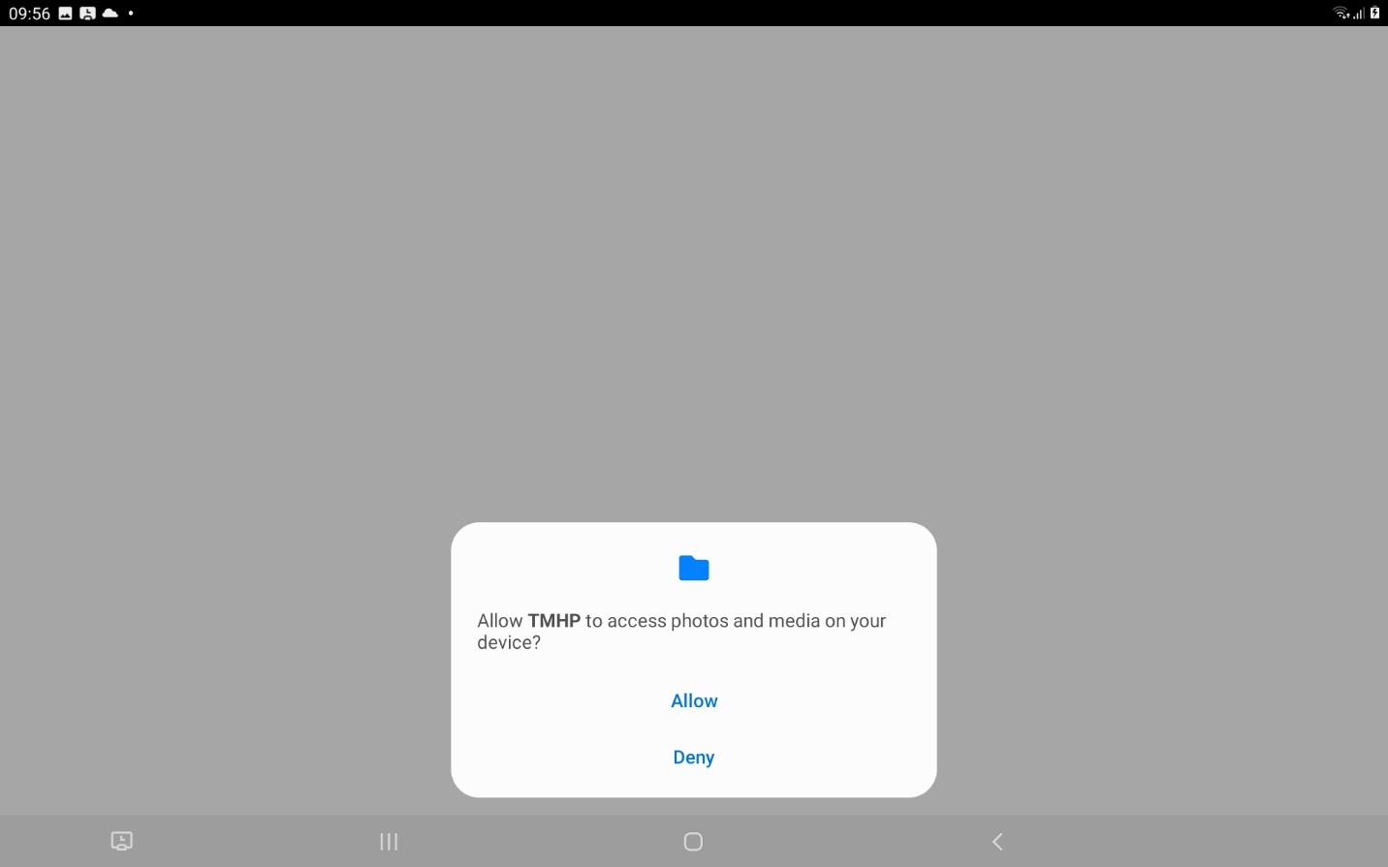

Img2 (Login page)

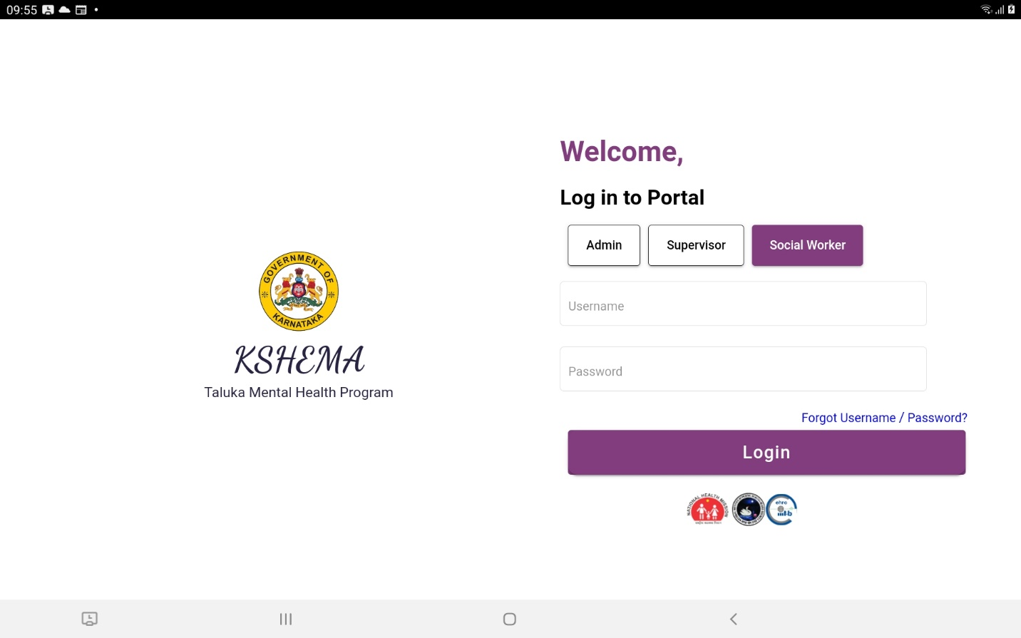

Img3 (Dashboard view – no data initially)

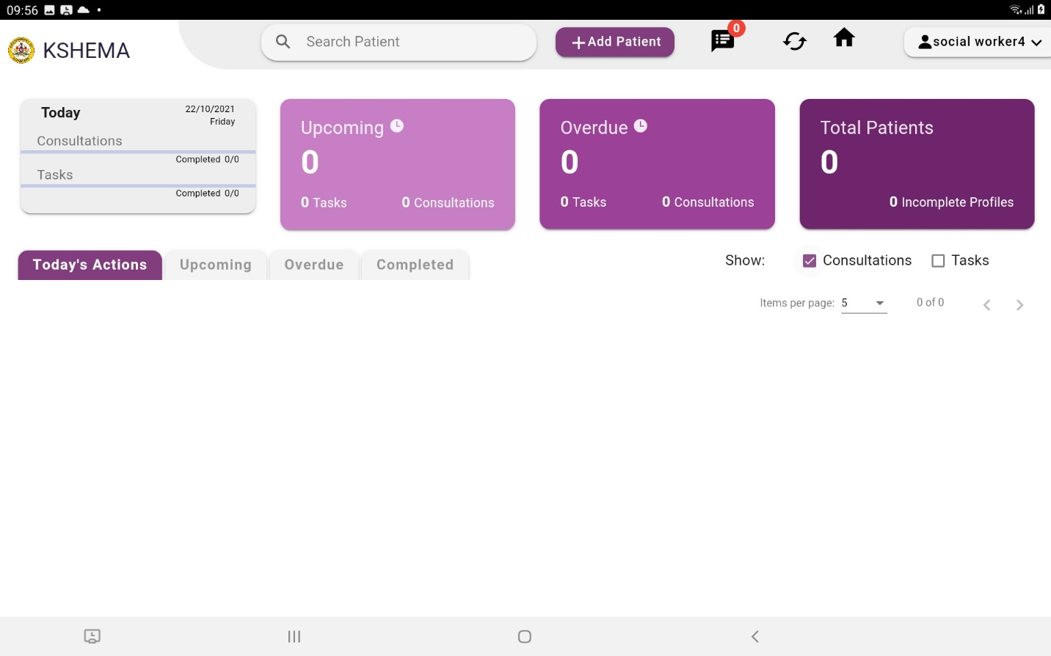

Img4 (Add patient page)

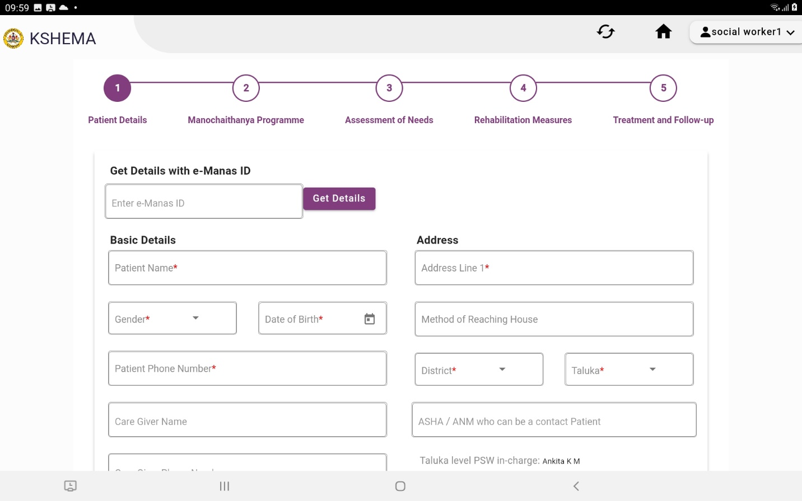

Img5 (Dashboard view – after adding patients - Consultation checkbox - right-middle- checked - showing upcoming consultations only)

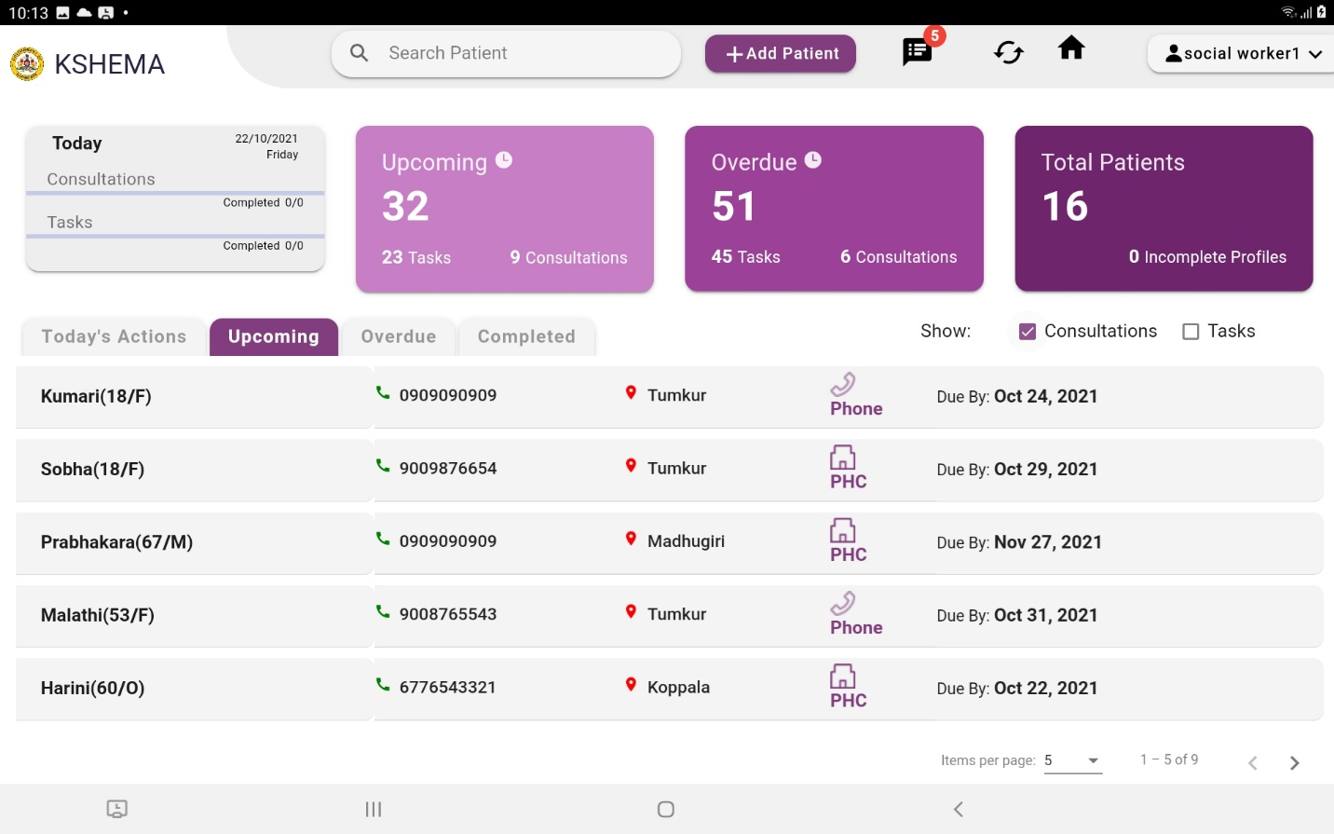

Img6 (Upcoming tasks – Tasks checkbox is checked, showing only upcoming tasks)

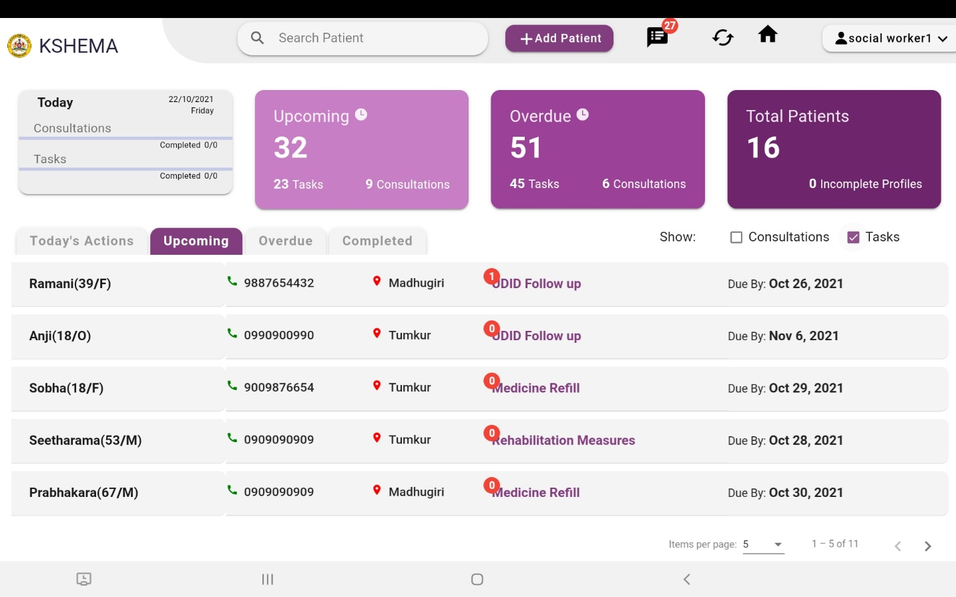

Img7 (All patients page)

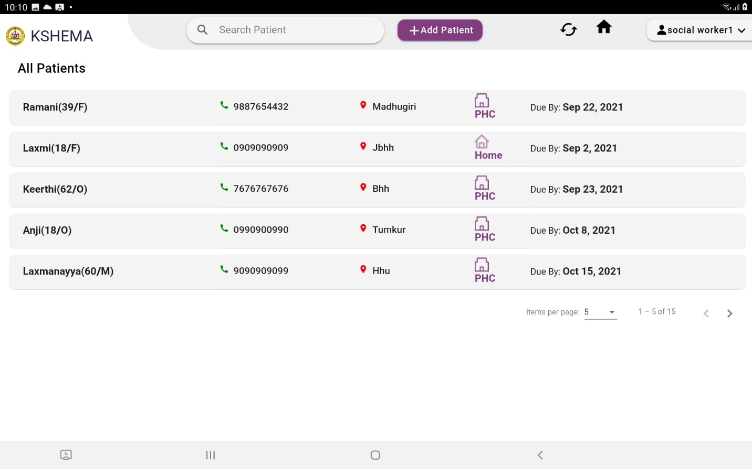

Img8 (Highlighting unread notes from the supervisor in the notification page)

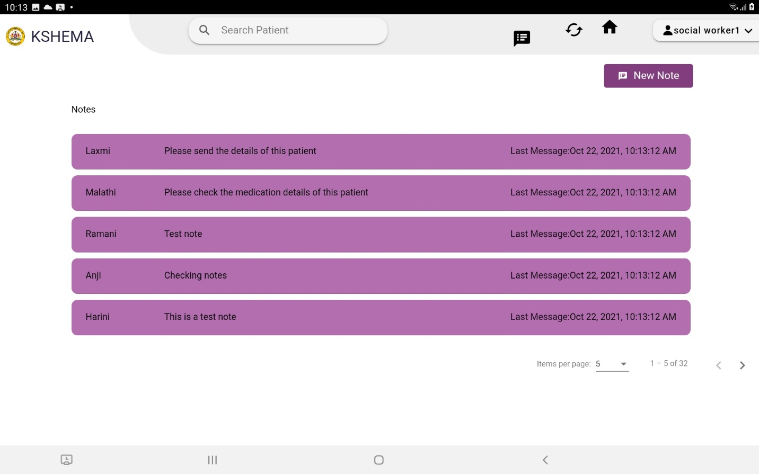

Img9 (Displaying read notes in the notification page)

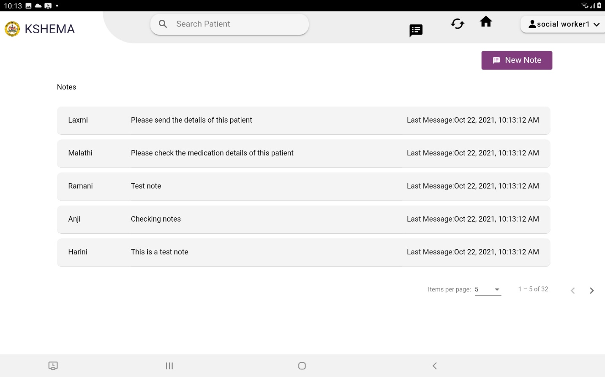

Img10 (Patient details page)

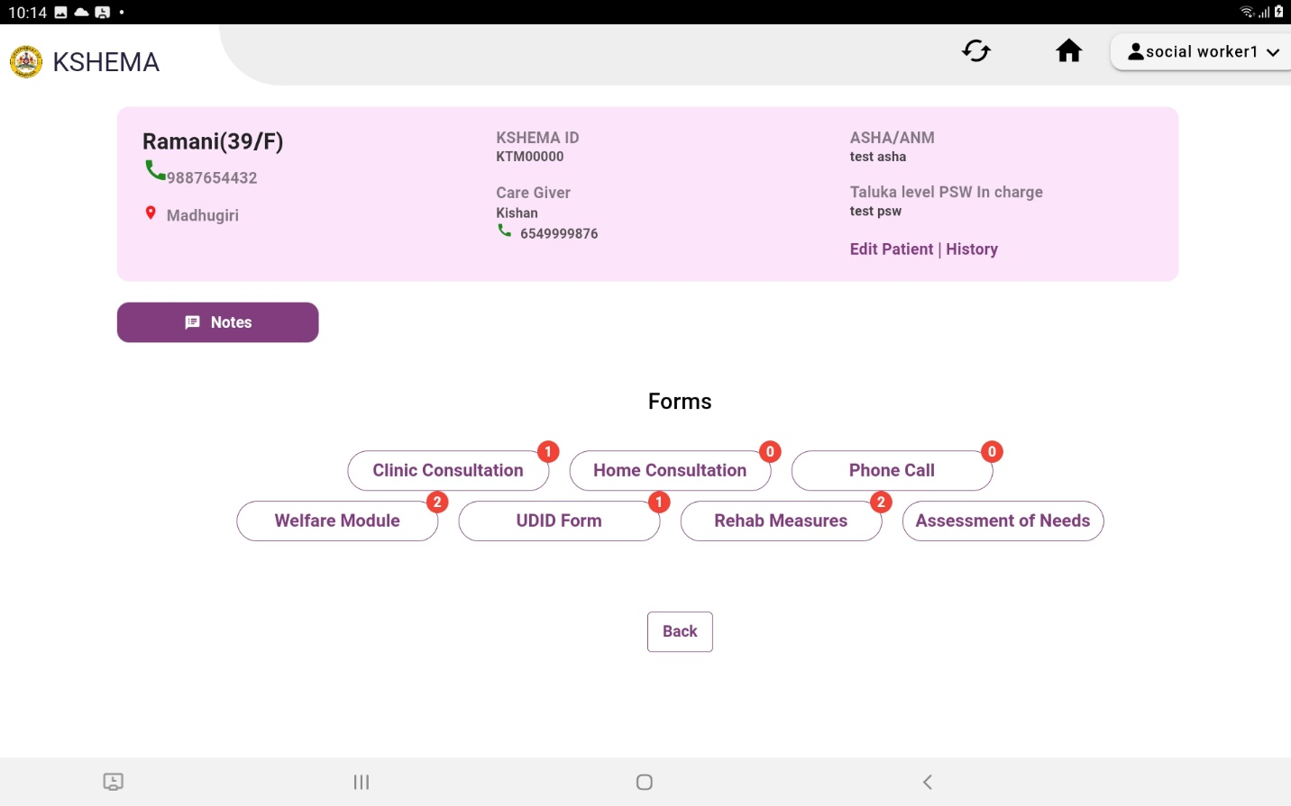

Img11 (Clinic consultation page)

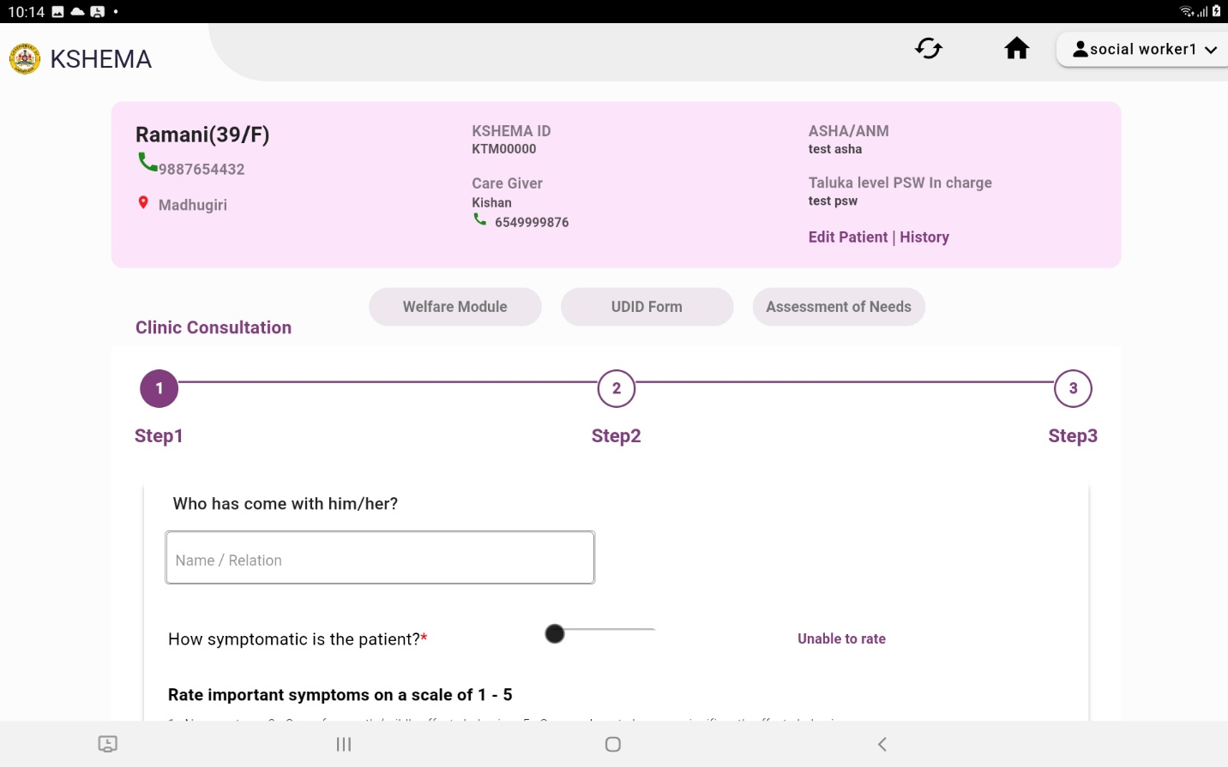

Img12 (Home consultation page)

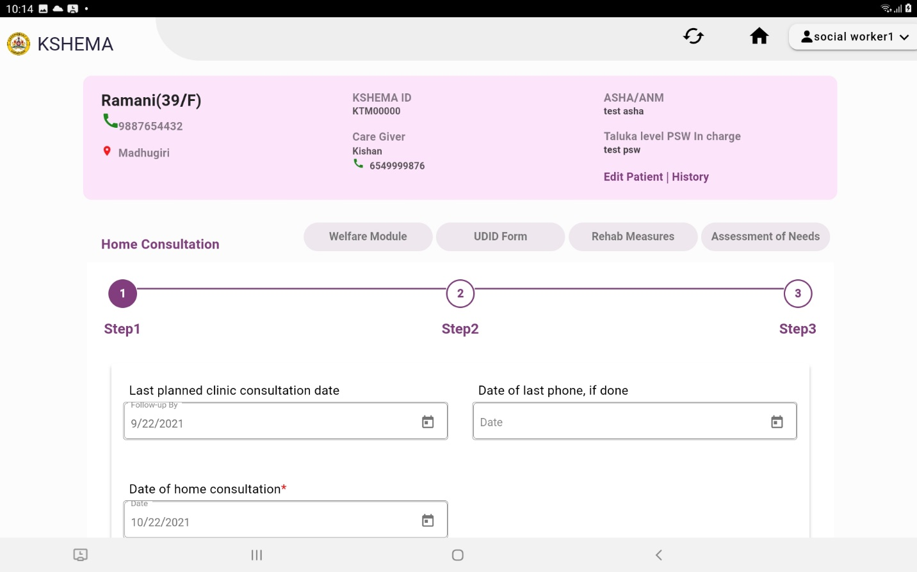

Img13 (Phone call page)

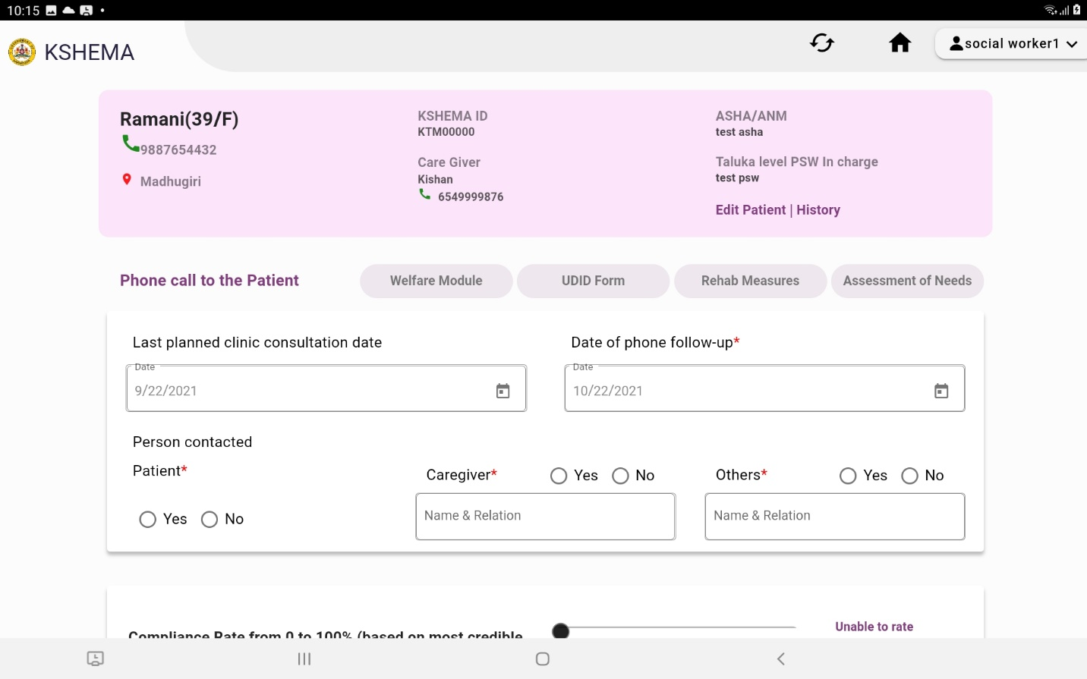

Img14 (Welfare page)

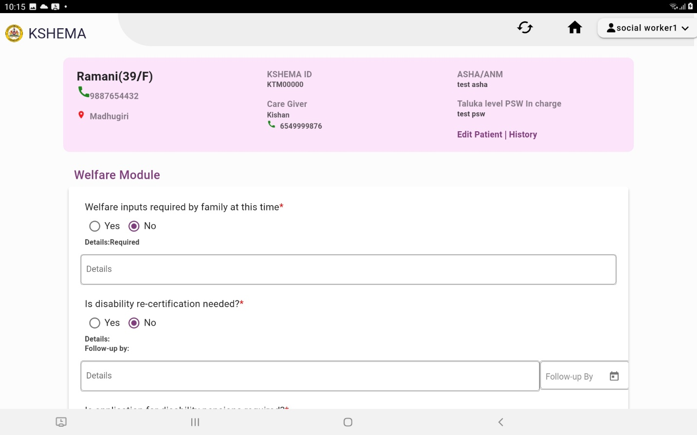

Img15 (UDID page)

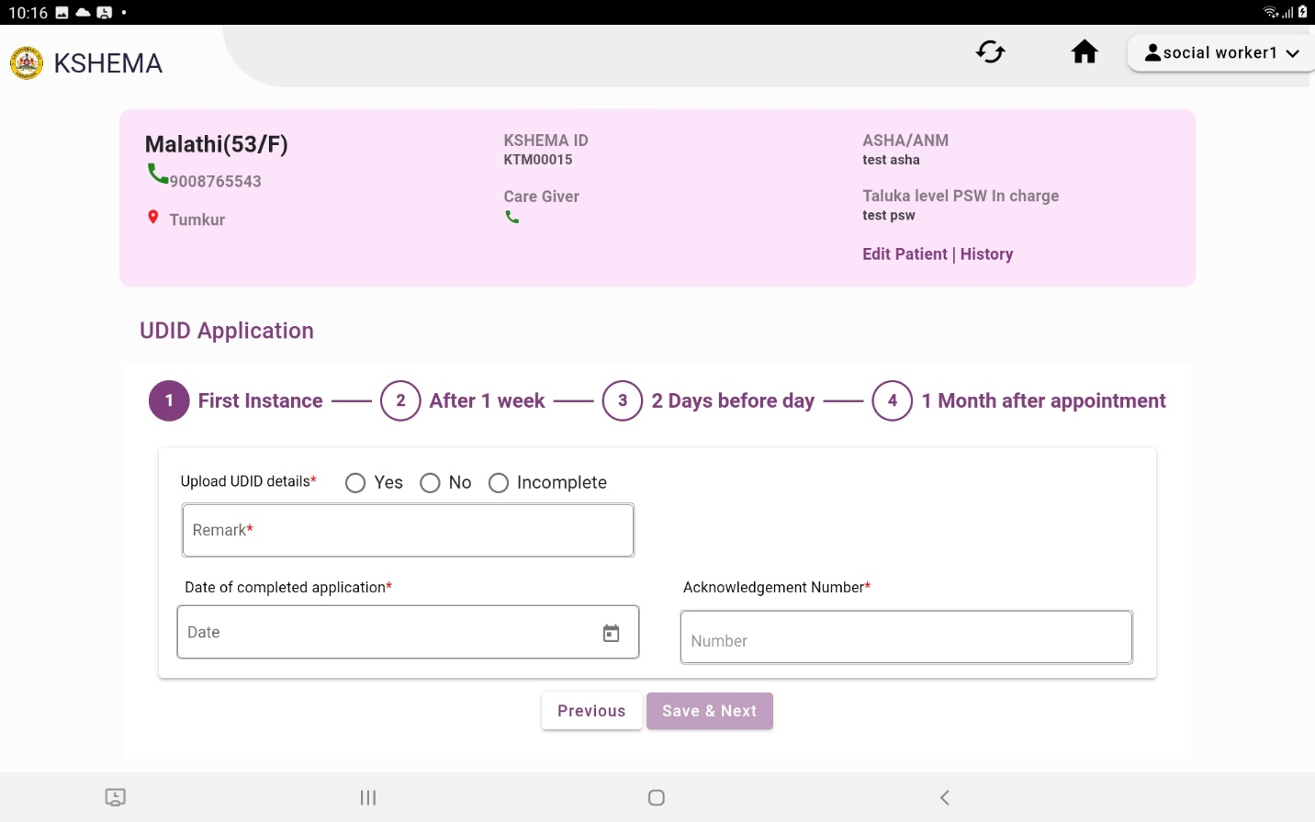

Img16 (Rehabilitation measures page)

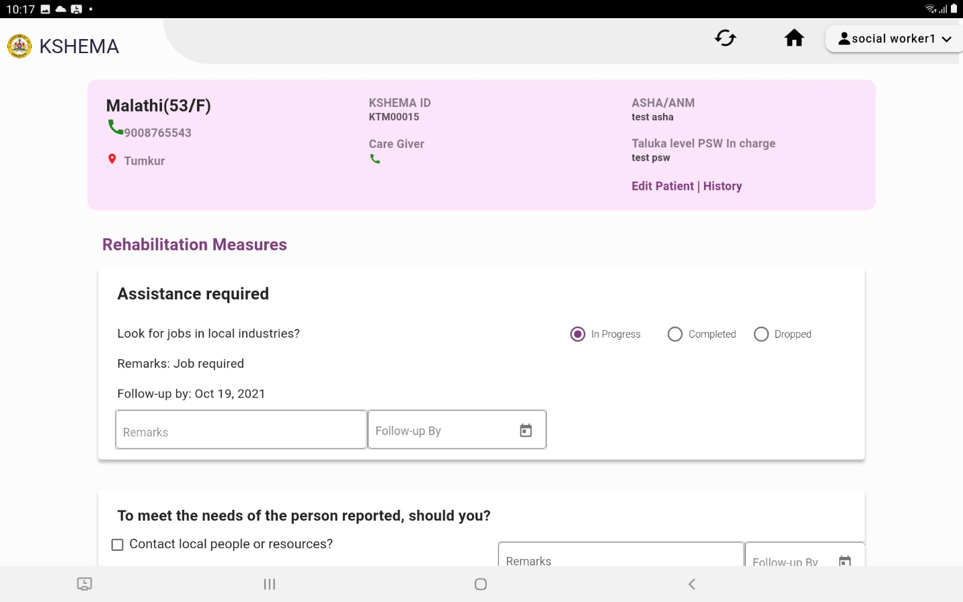

Img17 (Assessment of needs page)

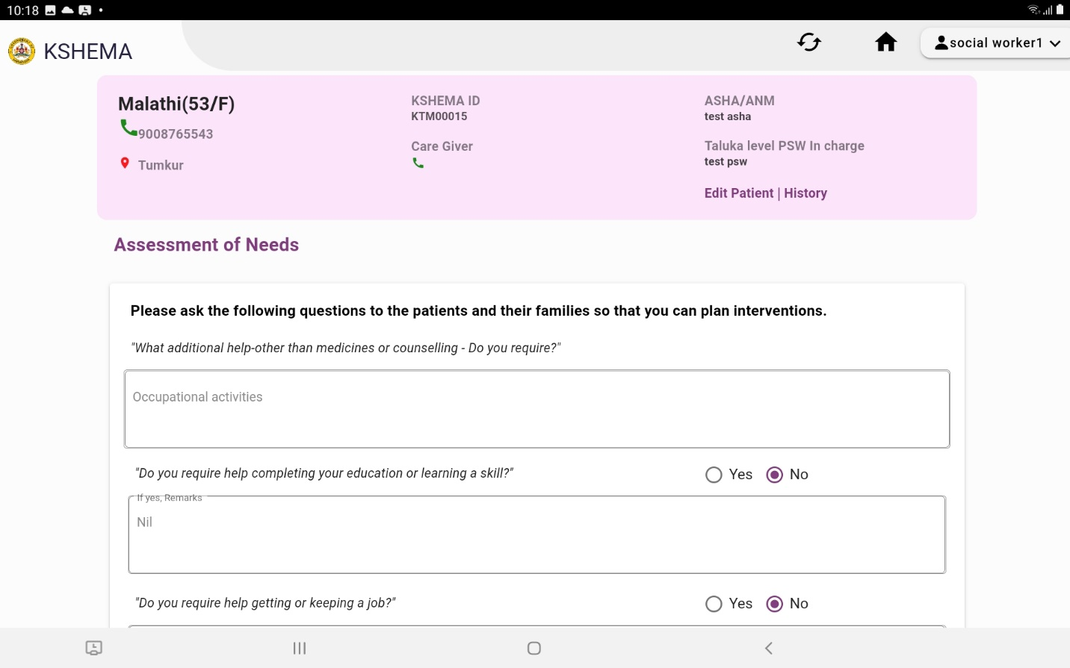

Img18 (Edit patient page)

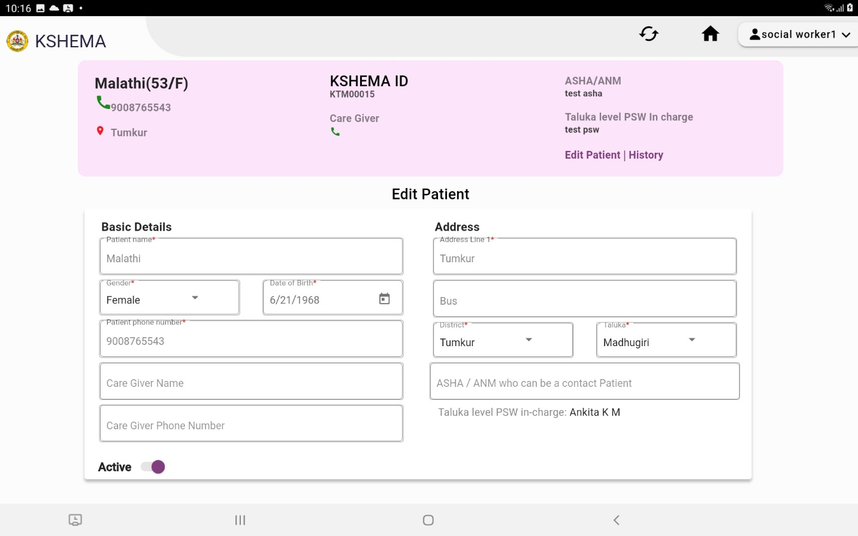

Img19 (History page)

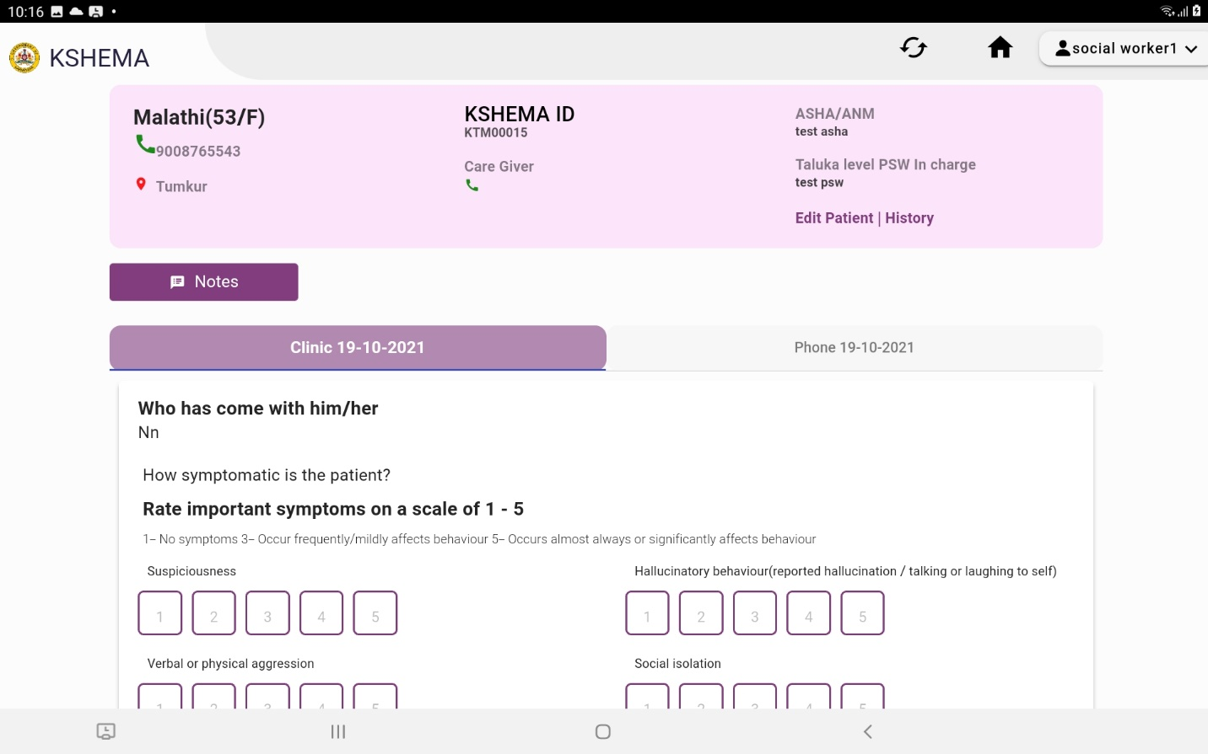

Img20 (Displays message while synchronizing to server database)

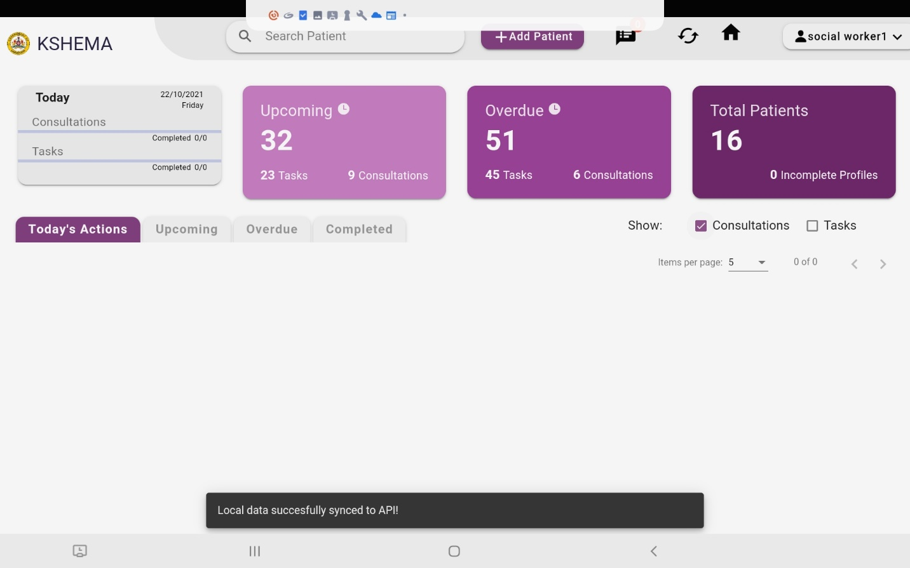

Author: Lalitha R S